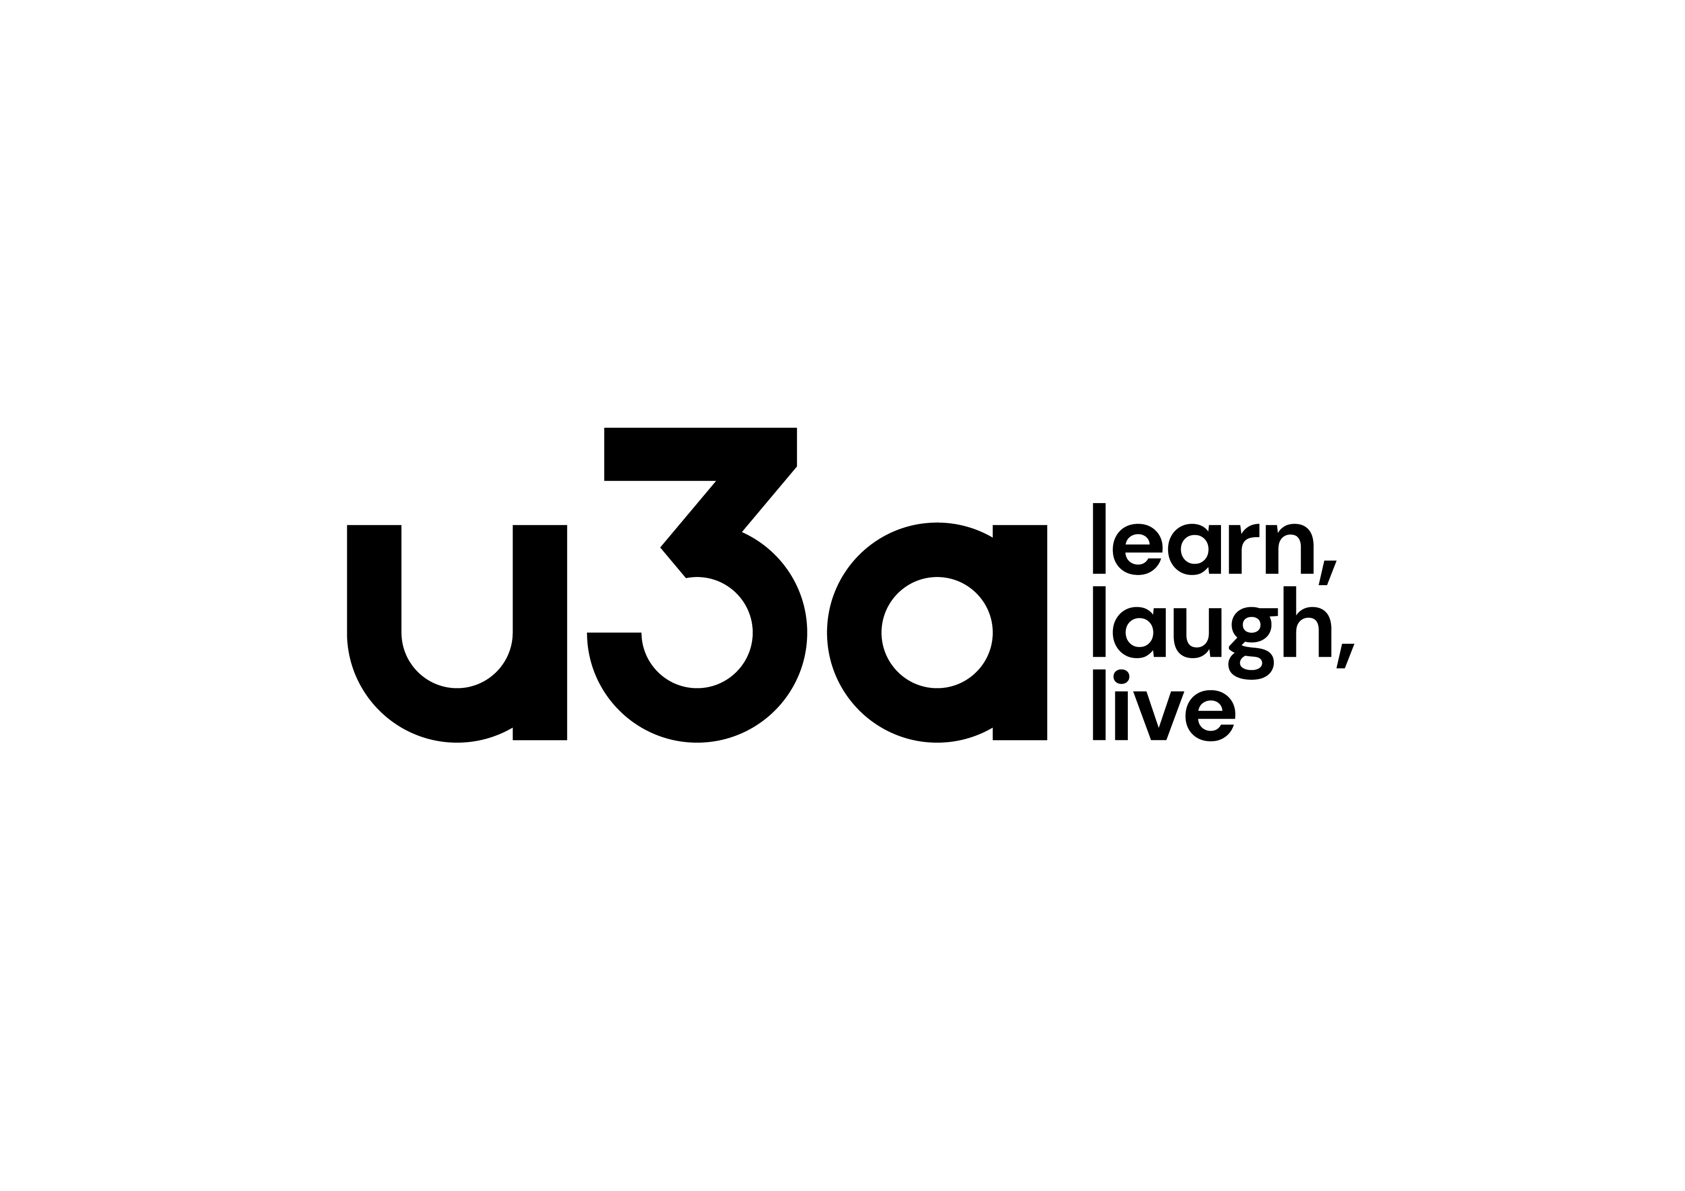
HOYLAKE WEST KIRBY & DISTRICT U3A Registered Charity number: 1164 NEW MEMBERS FORM 2026
(Please print)
Title | Forenames |  | Surname |  |  | Known as
Number/name |  | Street/name |  |  | Town | Postcode
Telephone |  |  |  | Mobile
Email address**

The name and contact number of anyone you would wish to be contacted in an emergency

** Please inform us if you change your email address as unless requested otherwise, all Newsletters and communications are sent by email.
‘Third Age Matters’ is a magazine supplied quarterly by The Third Age Trust. It is free of charge, but the Trust levy a charge of £5.00 per annum for postage. If you wish to receive this magazine, please tick here and add an additional amount of £5.00 to your membership fee of £15.00
Gift Aid Declaration (Taxpayers only) Registered Charity Number 1164889

I wish to Gift Aid my Annual Fee Payment. I should like Hoylake, West Kirby & District U3A to treat my Annual Fees and any other relevant payments as Gift Aid Donations from the date of this declaration until I notify you otherwise.
I am a UK Taxpayer and understand that if I pay Income Tax or Capital Gains Tax less than the amount of Gift Aid claimed on my payments in any one tax year, it is my responsibility to pay the difference.
I understand that the Charity will reclaim 25p of Tax from every pound (£) that I pay.

Signature: ……………………………………………………………………………………Date:……………………………………

Cheques made payable to: Hoylake, West Kirby & District U3A Privacy Statement: Hoylake, West Kirby & District U3A process your membership information so that we can keep you informed about events, groups and activities as part of your membership. We will store it securely & use it to communicate with you as a U3A member. Please tick your consent to this. Full details of our Privacy Statement, Terms and Conditions can be viewed on our website: www.u3asites.org.uk/hoylake
FOR OFFICE USE ONLY
AMOUNT PAID | CHEQUE NUMBER | CASH | BACS | CARD READER | T.A.M. INCLUDED
Where did you hear about us?

RECEIVED BY: |  | DATE:

